Program Test Log
Test #1 | Type of Test | Reason for Test | Test Status
 | Tried edge cases, 100, 0, over 100, empty submissions | to test input check | Passed
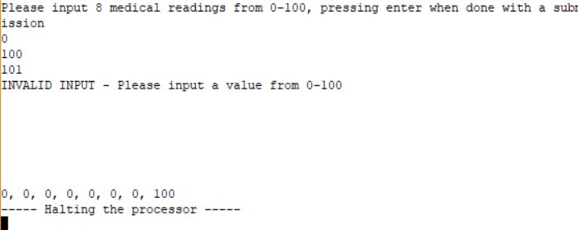
Test #2 | Type of Test | Reason for Test | Test Status
 | Tried signed entries and non number entries | to test input check | Passed
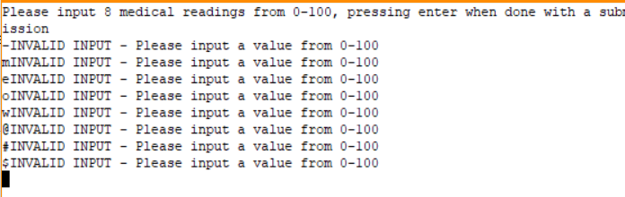
Test #3 | Type of Test | Reason for Test | Test Status
 | Tried all of the same entry | To test Print and Sort | Passed
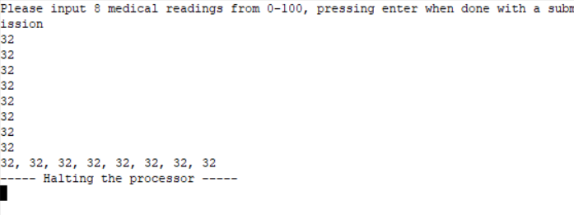
Test #4 | Type of Test | Reason for Test | Test Status
 | Already Sorted Values | To test Print and Sort | Passed
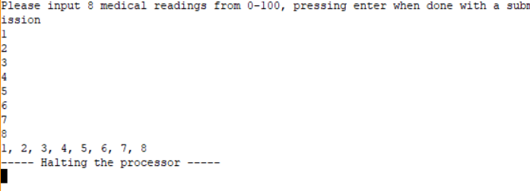
Test #5 | Type of Test | Reason for Test | Test Status
 | Reverse Sorted Values | To test Print and Sort | Passed
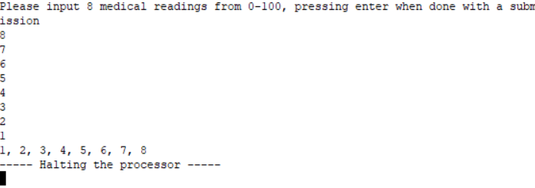
Test #6 | Type of Test | Reason for Test | Test Status
 | Random Values from a Random # Generator | To test entire Program | Passed
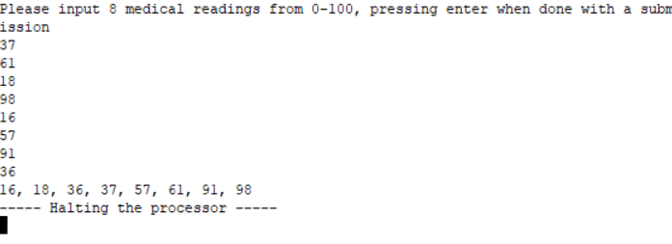
Test #7 | Type of Test | Reason for Test | Test Status
 | Normal test, Values from Project Criteria | To Test Entire Program | Passed
